Cell Culture Laboratory Management System
Database Project Report
Course: Fundamentals of Databases
Student Name :logyin khaled ragab
Student ID: 221001984

1. Introductio
The Cell Culture Laboratory Management System is a relational database designed to organize information generated during cell-culture laboratory work. The database connects researchers, cell lines, experiments, culture vessels, incubators, media, passages, observations, cryopreserved stocks, instruments, and contamination tests.
2. Problem Statement
Cell-culture laboratories handle many related records. Keeping these records in separate or unstructured files can make it difficult to follow experiments, identify responsible researchers, track cell-line usage, monitor observations, and retrieve contamination-test results. The proposed database provides a centralized relational structure for these activities.
3. Objectives
- Store and organize laboratory researchers and their roles.
- Maintain information about cell lines and their maintenance.
- Track experiments and their associated cell lines.
- Track culture vessels, incubators, media and passage events.
- Record observations and contamination-test results.
- Manage cryopreserved cell stocks and laboratory instruments.
- Use primary keys, foreign keys and constraints to maintain data integrity.
- Provide SQL queries, views and a trigger for useful database operations and validation.
4. Database Design
The final ER diagram contains 12 main tables. Primary keys identify records, while foreign keys connect related entities. The Experiment–CellLine many-to-many relationship is implemented through the associative table Experiment_CellLine.
Table | Main Key(s) | Purpose
Researcher | ResearcherID (PK) | Stores researcher details.
CellLine | CellLineID (PK), MaintainedBy (FK) | Stores cell-line information and its maintainer.
Experiment | ExperimentID (PK), ResearcherID (FK) | Stores experiment details, dates, objectives and status.
Experiment_CellLine | ExperimentID + CellLineID (composite PK/FK) | Associative table for the Experiment–CellLine M:N relationship.
Incubator | IncubatorID (PK) | Stores incubator information and environmental settings.
CultureVessel | VesselID (PK), CellLineID/IncubatorID (FK) | Stores culture-vessel information and assignments.
Media | MediaID (PK) | Stores culture-media information and expiration dates.
Passage | PassageID (PK), VesselID/MediaID/PerformedBy (FK) | Records cell-passaging events.
Observation | ObservationID (PK), VesselID/ObservedBy (FK) | Records observations and confluency.
CryopreservedStock | StockID (PK), CellLineID (FK) | Records frozen cell stocks.
Instrument | InstrumentID (PK) | Stores laboratory instrument information.
ContaminationTest | TestID (PK), PassageID/InstrumentID/PerformedBy (FK) | Records contamination testing results.
5. Entity Relationship Diagram (ERD)
The following diagram is the final ERD generated for the Cell Culture Laboratory database. It shows the tables, their attributes, primary/foreign keys and relationships.
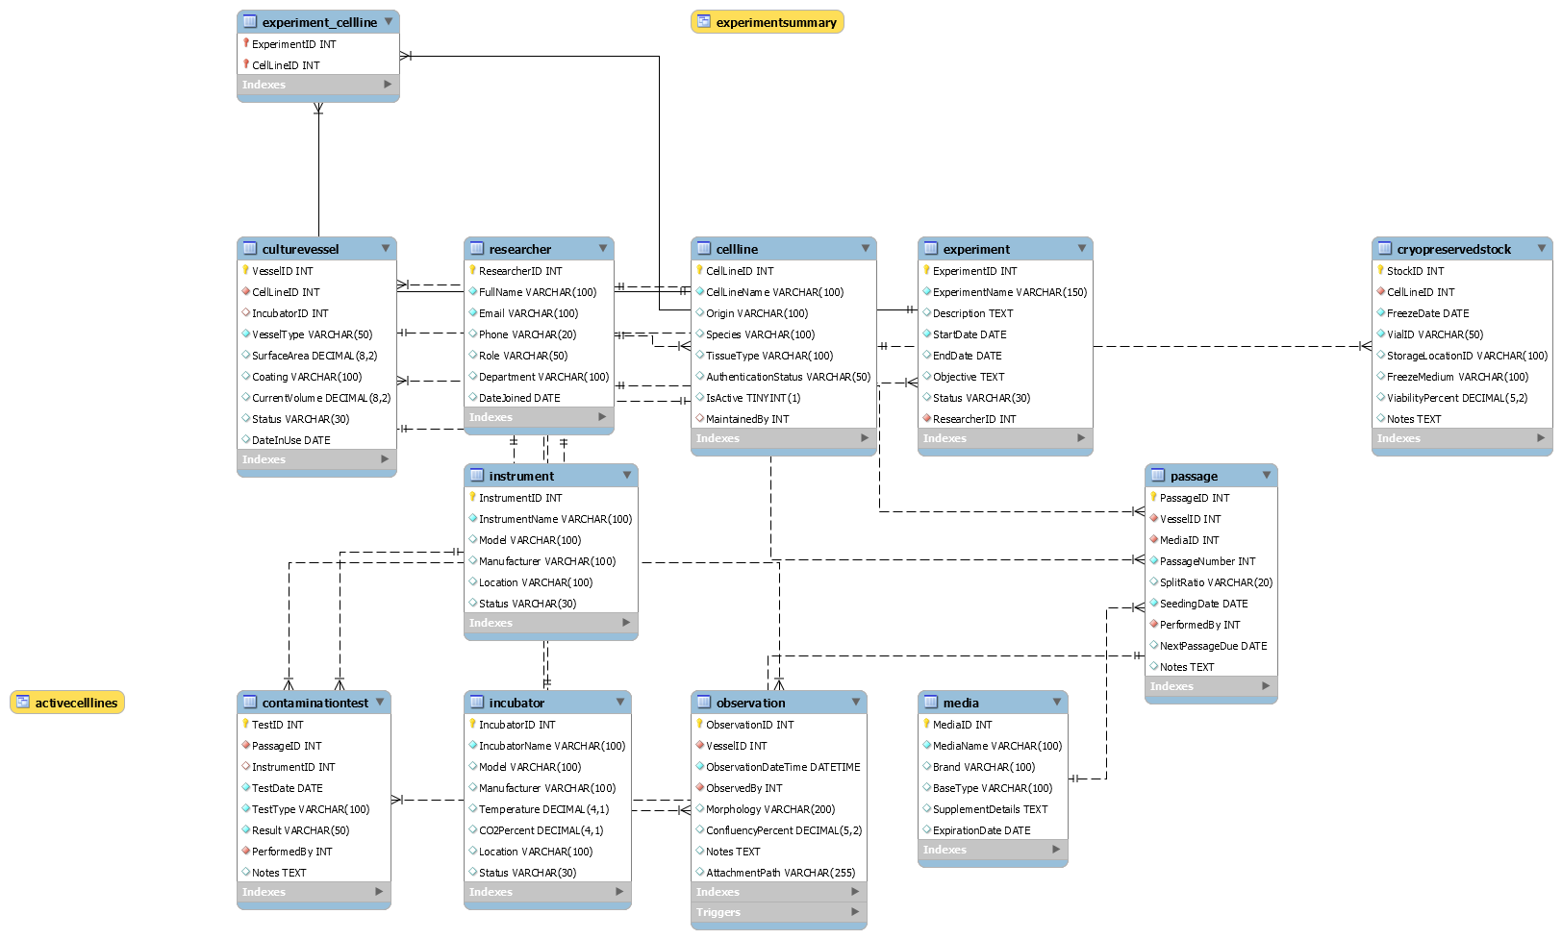
Figure 1. Final Entity Relationship Diagram (ERD).

6. Relationships and Cardinalities
Relationship | Cardinality
Researcher → CellLine | 1 : M
Researcher → Experiment | 1 : M
Experiment ↔ CellLine | M : N, resolved by Experiment_CellLine
CellLine → CultureVessel | 1 : M
Incubator → CultureVessel | 1 : M
CultureVessel → Passage | 1 : M
Media → Passage | 1 : M
Researcher → Passage | 1 : M
CultureVessel → Observation | 1 : M
Researcher → Observation | 1 : M
CellLine → CryopreservedStock | 1 : M
Passage → ContaminationTest | 1 : M
Instrument → ContaminationTest | 1 : M
Researcher → ContaminationTest | 1 : M
7. Integrity Constraints
- Researcher.Email is UNIQUE.
- Experiment end date cannot be earlier than the start date.
- Incubator temperature must be greater than zero.
- Incubator CO2 percentage must be between 0 and 100.
- Culture-vessel surface area must be positive when supplied.
- Culture-vessel current volume cannot be negative.
- Passage number cannot be negative.
- Observation confluency must be between 0 and 100.
- Cryopreserved-stock viability must be between 0 and 100.
- VialID in CryopreservedStock is UNIQUE.
- Foreign-key actions use appropriate CASCADE, RESTRICT or SET NULL behavior.
8. Database Implementation
The database was implemented in MySQL using CREATE DATABASE, CREATE TABLE, foreign-key constraints, CHECK constraints, views, INSERT statements, SELECT queries and a trigger. The database was successfully executed in MySQL Workbench.
9. Test Data and SQL Results
The database was populated with sample records. The displayed execution results show successful INSERT operations, including 10 records inserted for Media, Instrument, Experiment, Experiment_CellLine, Passage, Observation, CryopreservedStock and ContaminationTest, with no duplicates or warnings in the shown operations.
10. Query 8 – Contamination Test Results
The final screenshot shows the result of the contamination-test query. The result grid contains TestID, TestType, Result, PerformedBy and TestDate. Ten records are displayed. Most tests are reported as Negative, while TestID 8 is Inconclusive and is associated with the note to repeat the test in the underlying sample data.
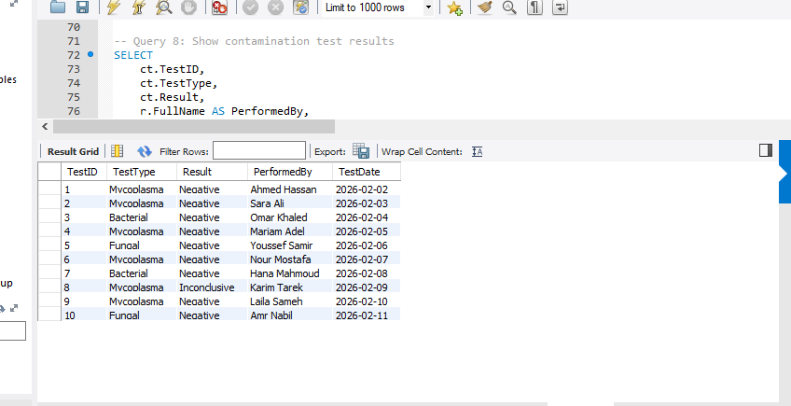
Figure 2. MySQL Workbench result grid for contamination-test results.
11. Views
Two database views were created successfully:
- ActiveCellLines: returns active cell lines together with species, tissue type and the researcher maintaining them.
- ExperimentSummary: combines experiment information with the responsible researcher and associated cell line.
Both views were executed successfully and returned 10 rows in the recorded execution results.
12. Trigger
The CheckObservationConfluency trigger is a BEFORE INSERT trigger on the Observation table. It validates ConfluencyPercent and rejects values outside the 0–100 range with a database error message.
13. Normalization
The design separates different subjects into dedicated tables and uses keys to connect them. Attributes are stored as atomic values, repeated groups are avoided, and relationship data is separated through the associative Experiment_CellLine table. This supports a design consistent with Third Normal Form (3NF) for the presented relational schema.
14. Testing and Verification
- Database and tables were created successfully.
- Sample data was inserted successfully.
- SQL query result grids were generated in MySQL Workbench.
- ActiveCellLines and ExperimentSummary views were created and queried successfully.
- The CheckObservationConfluency trigger was created successfully.
- The ERD was generated and reviewed against the implemented tables and relationships.
15. Limitations
The current project focuses on the relational database layer and uses sample data for demonstration. The AttachmentPath field stores a file path/reference rather than implementing file storage. A graphical application interface is outside the scope of this database submission.
16. Conclusion
The Cell Culture Laboratory Management System provides a structured relational solution for managing core cell-culture laboratory information. The final design includes 12 related tables, an associative table for the many-to-many relationship, integrity constraints, sample data, SQL queries, two views, and a validation trigger. The successful MySQL Workbench results and ERD demonstrate the implemented database structure.

